STEP 1: Setting up Project
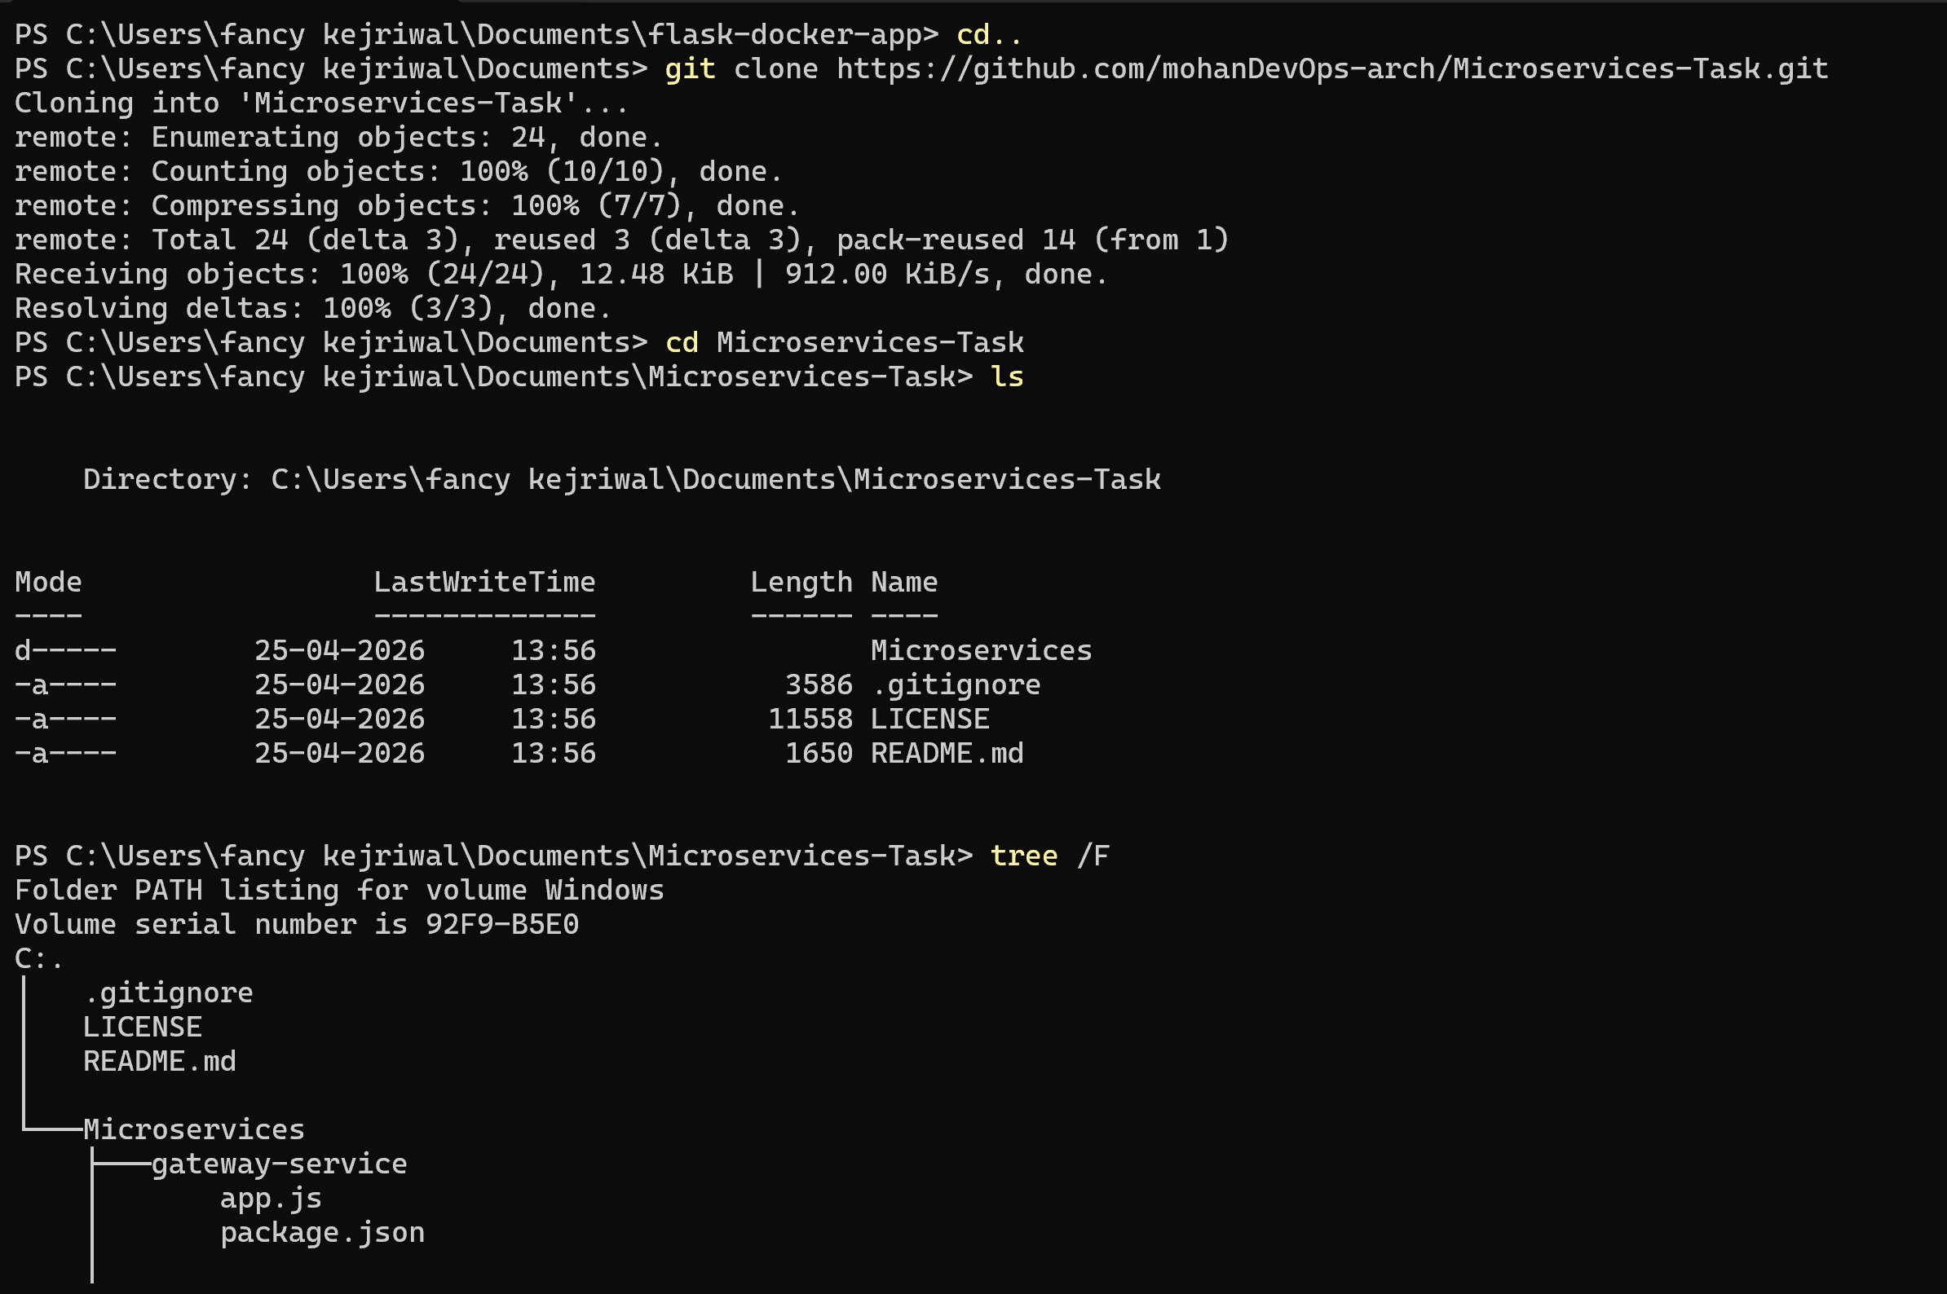
STEP 2: Created Service folder and created one Docker file inside EACH service folder
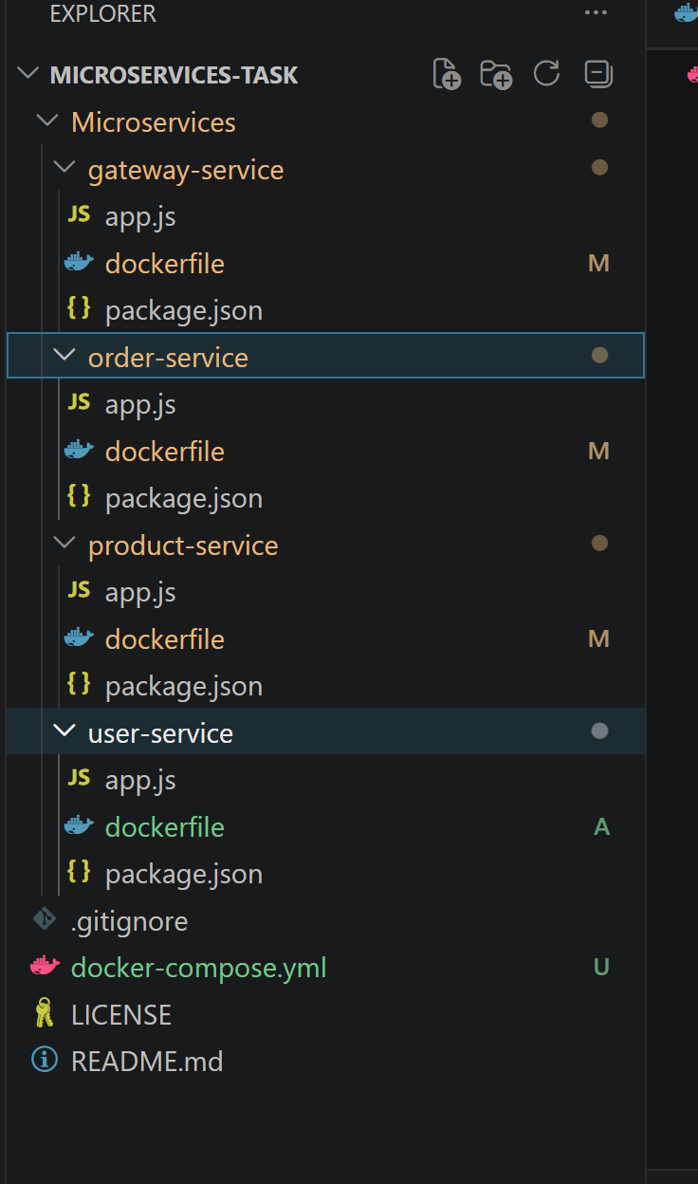
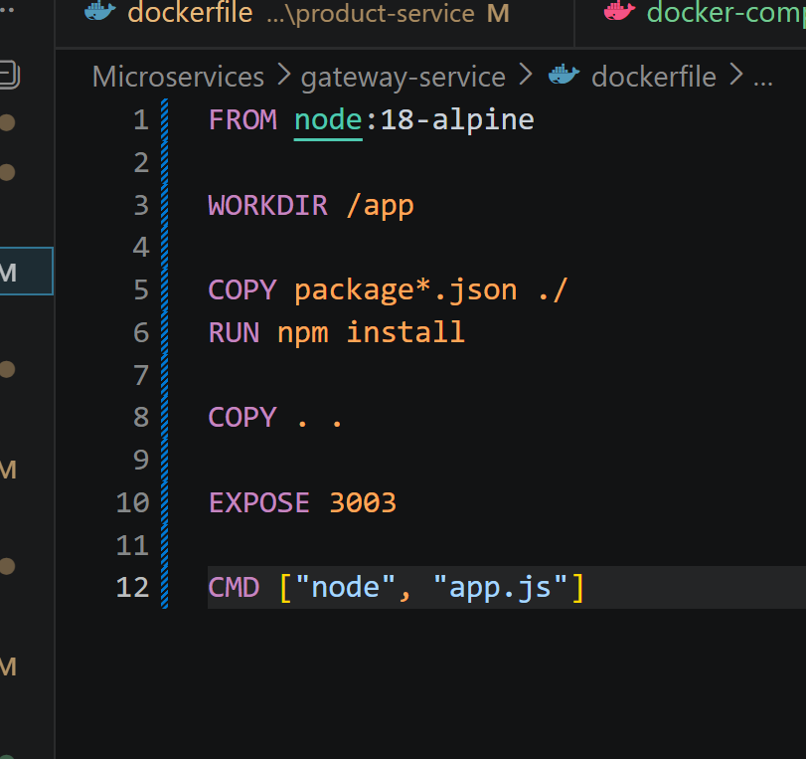
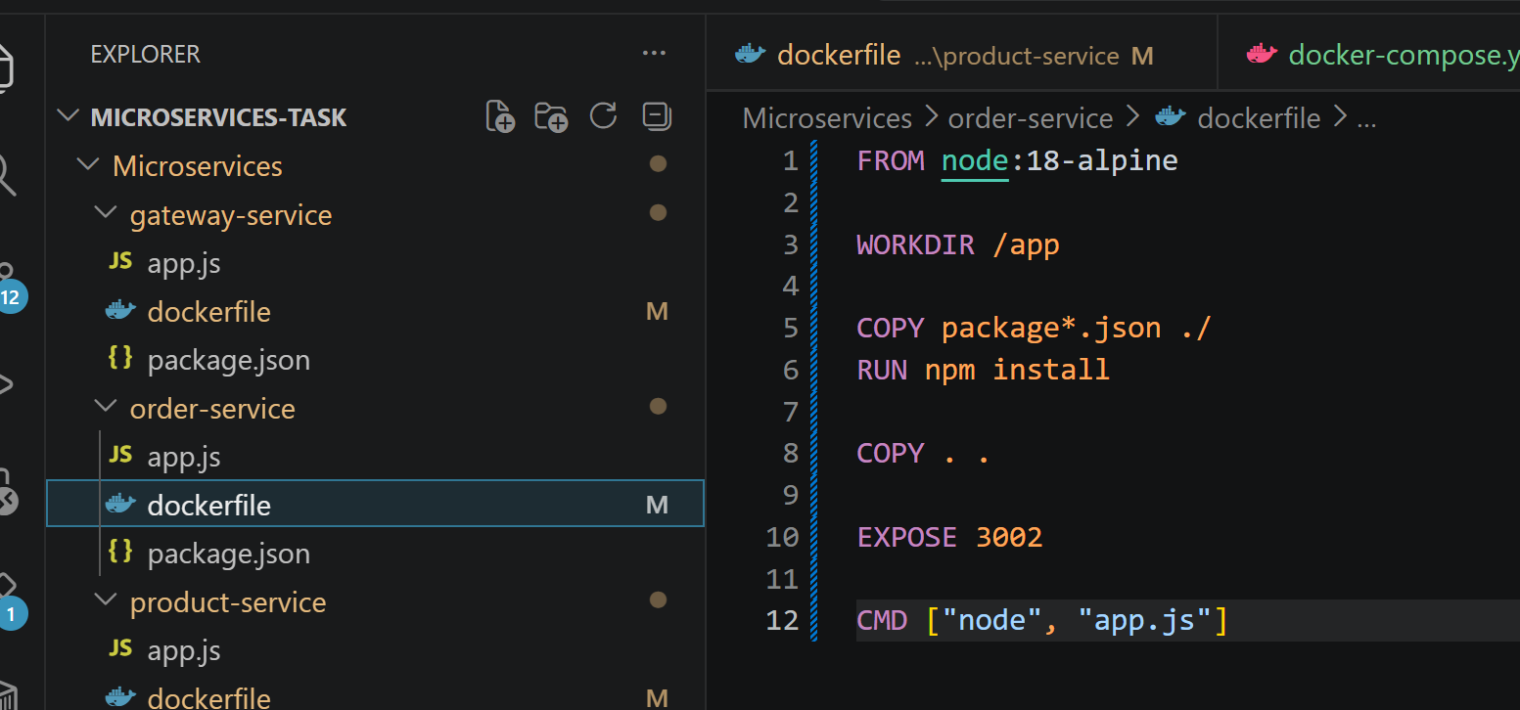
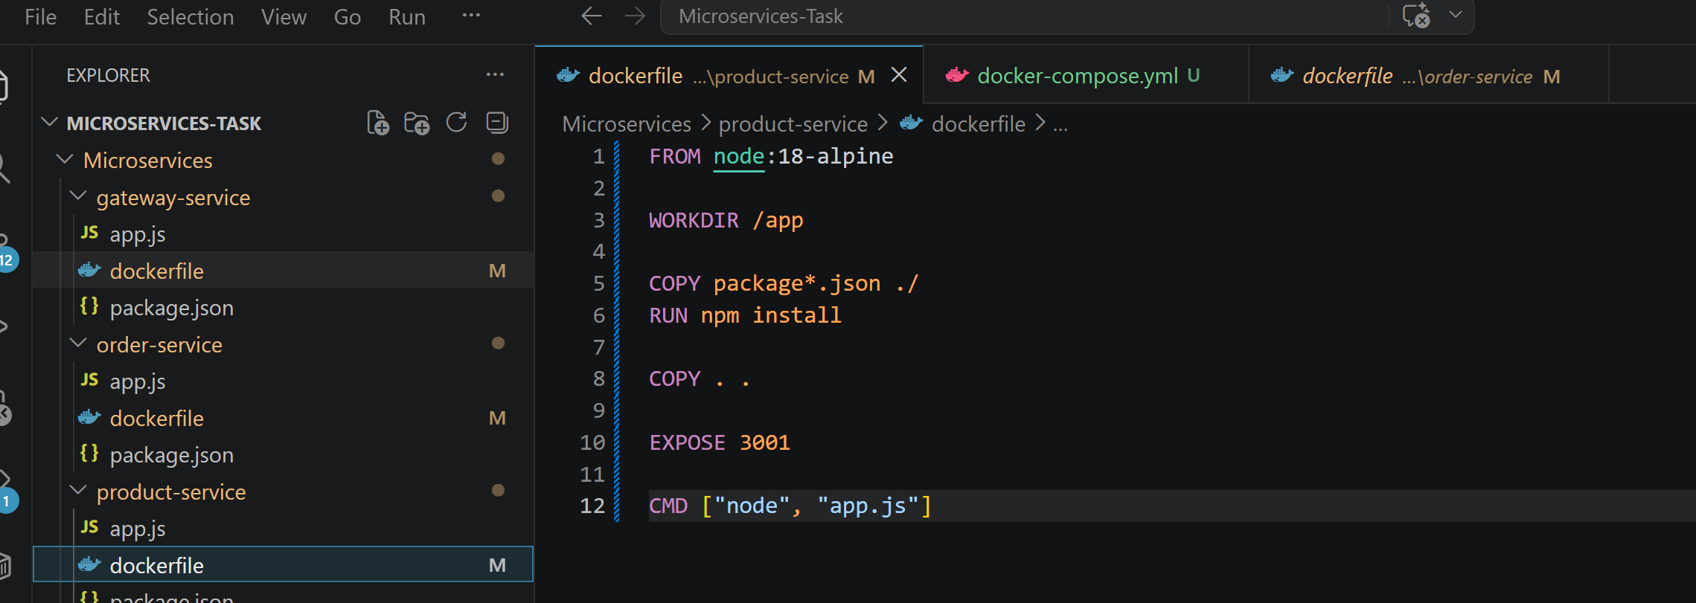
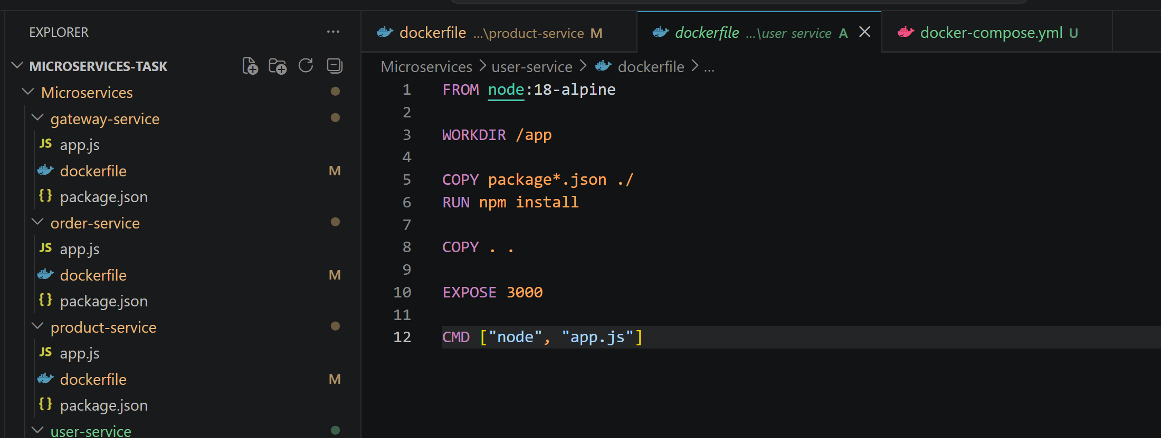
STEP 3- Create docker-compose.yml
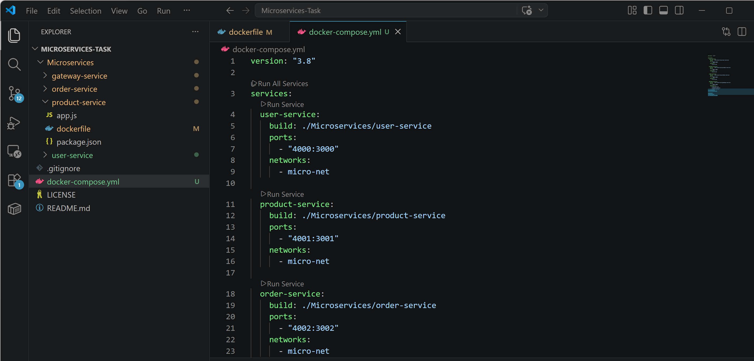
STEP 5: Running Everything
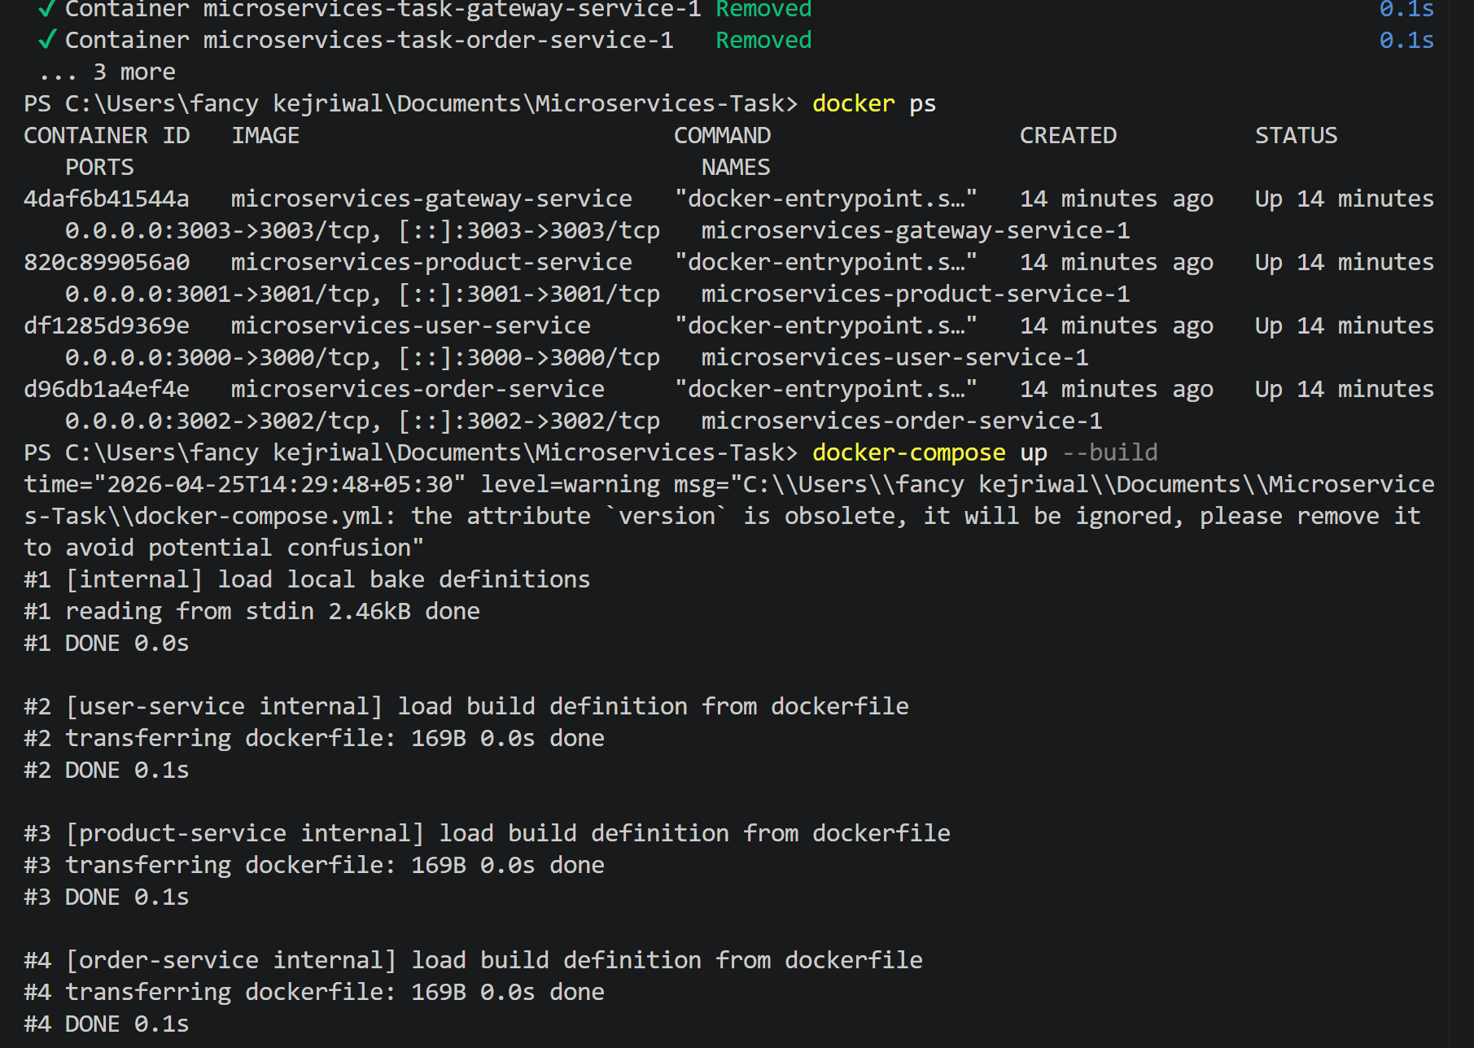
All services are now running:
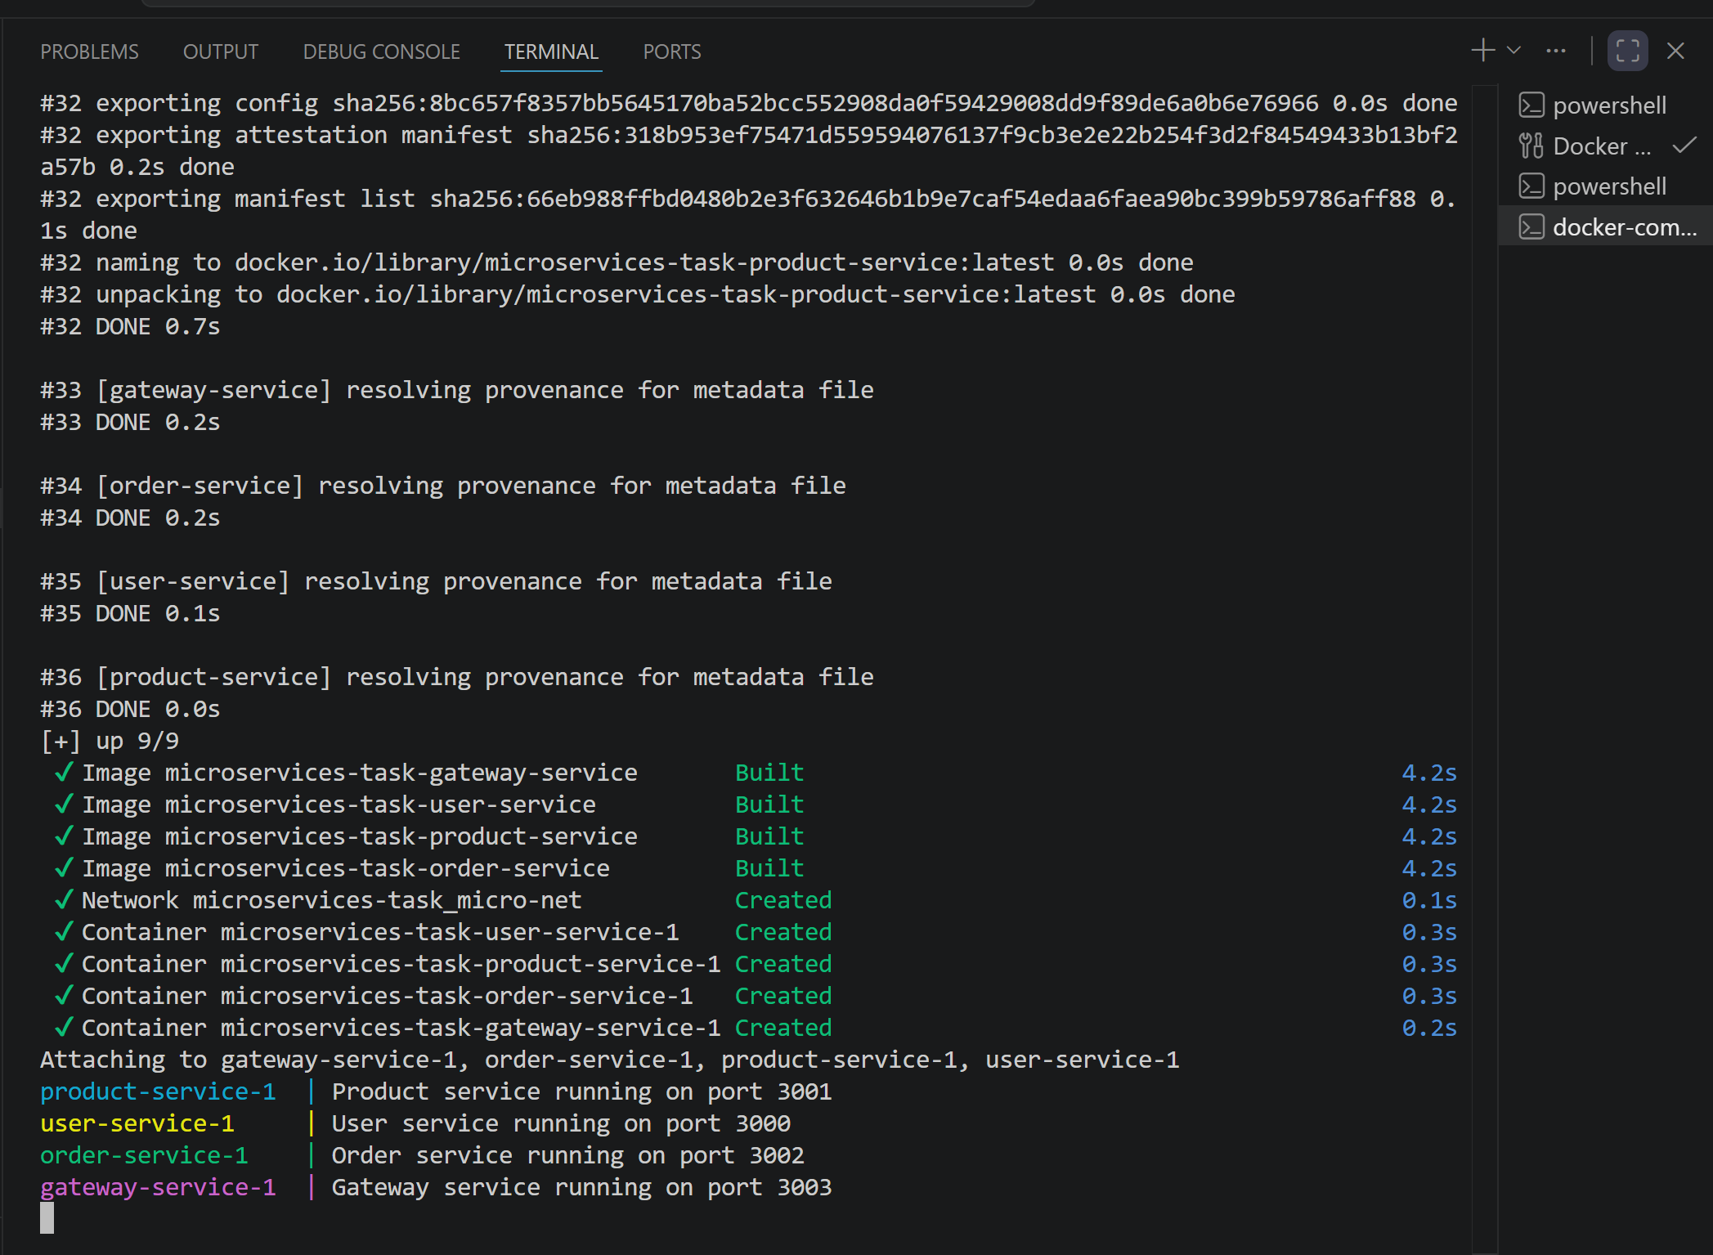

Now Testing in browsers
Direct Services
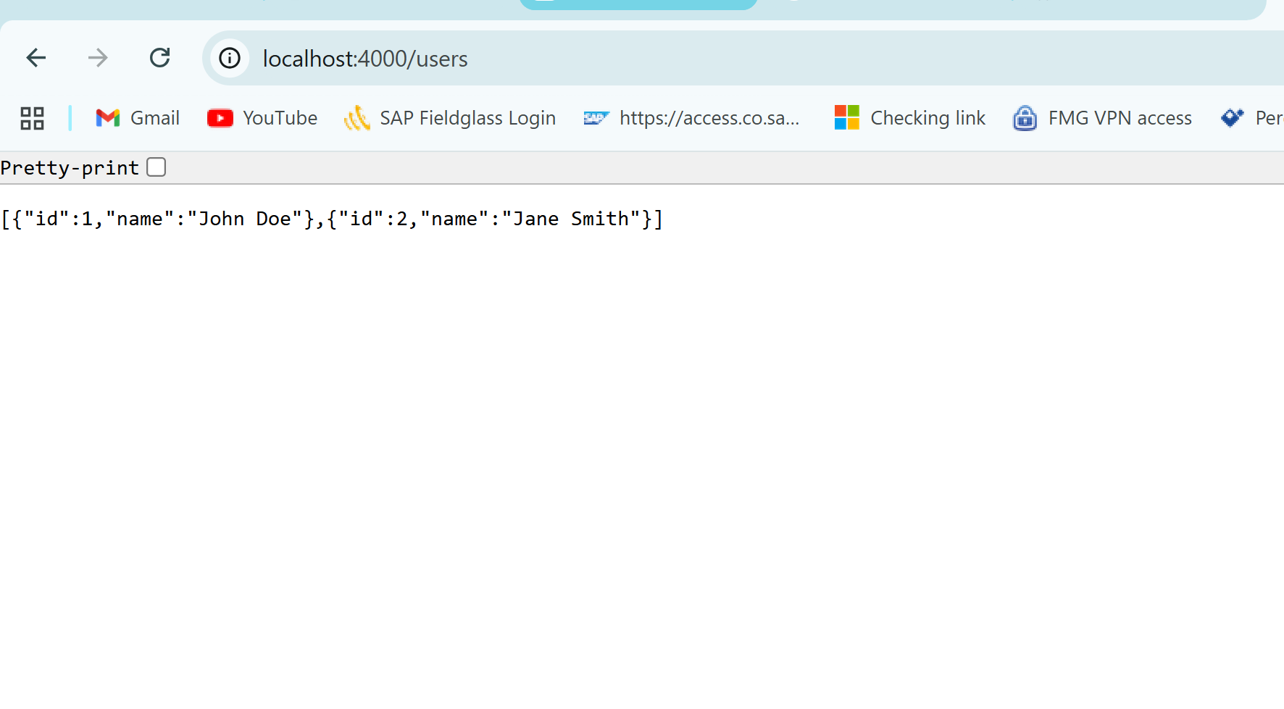
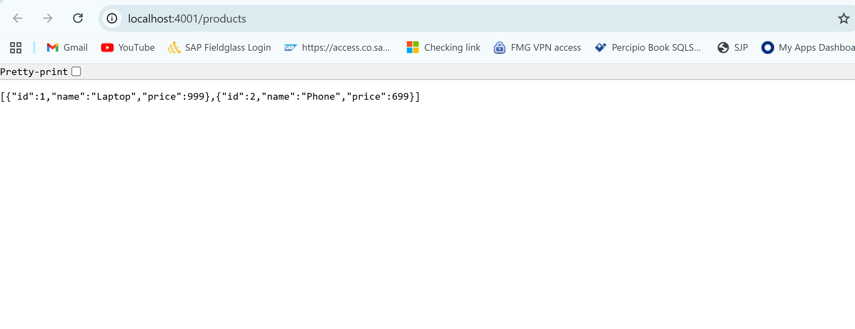
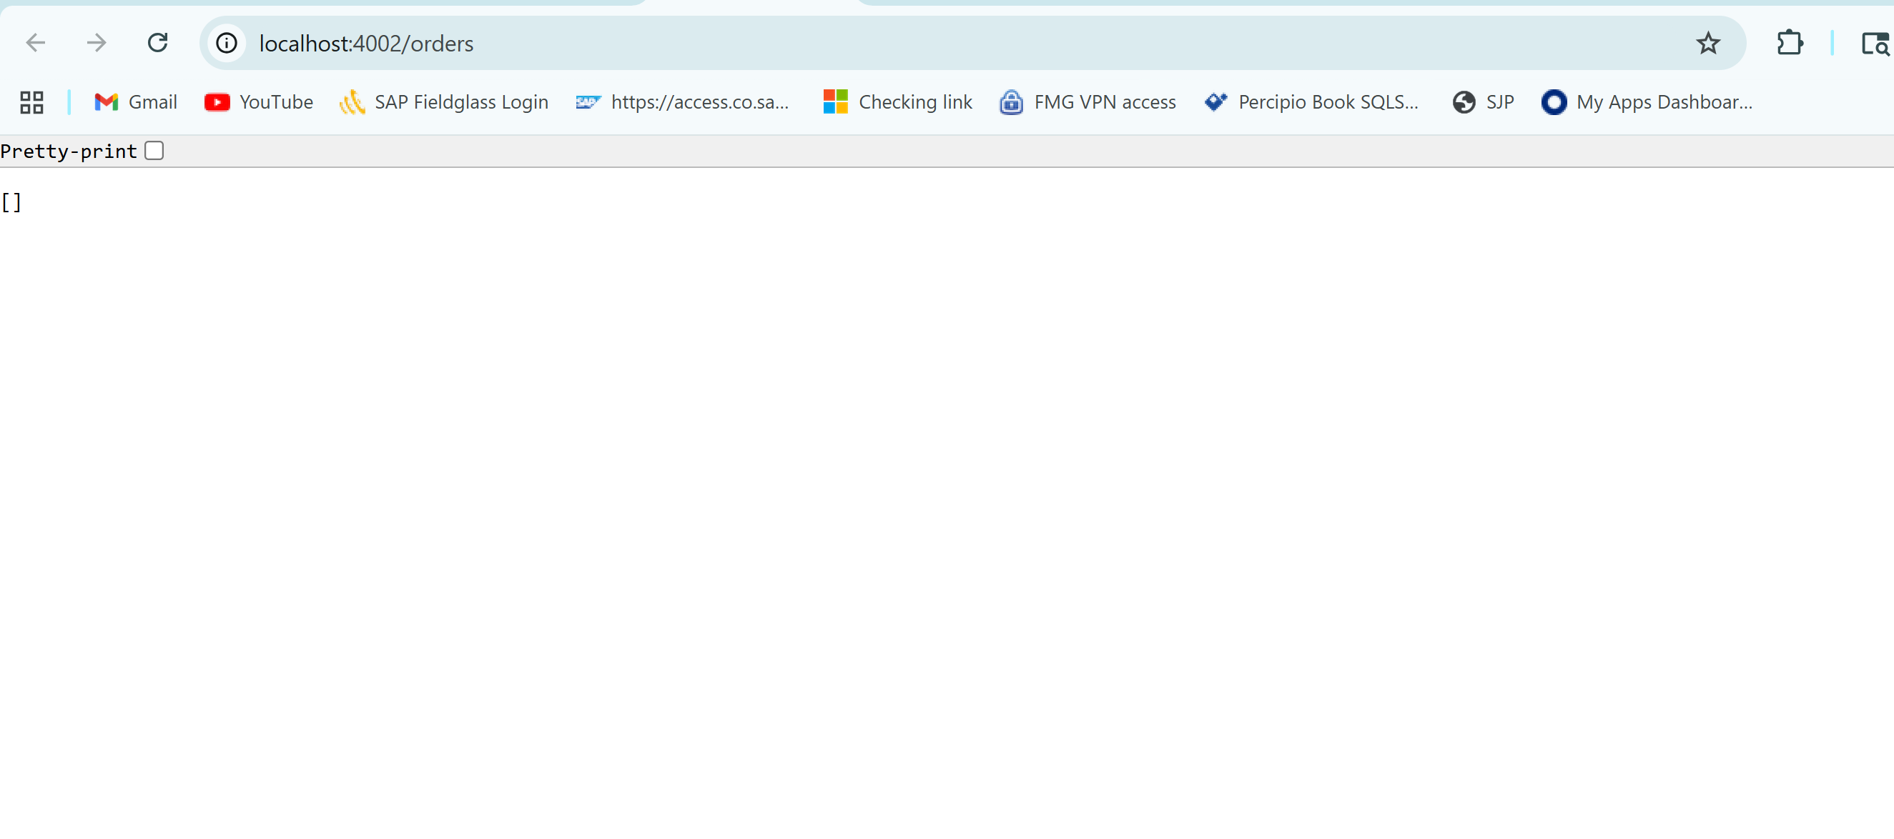

Gateway Services
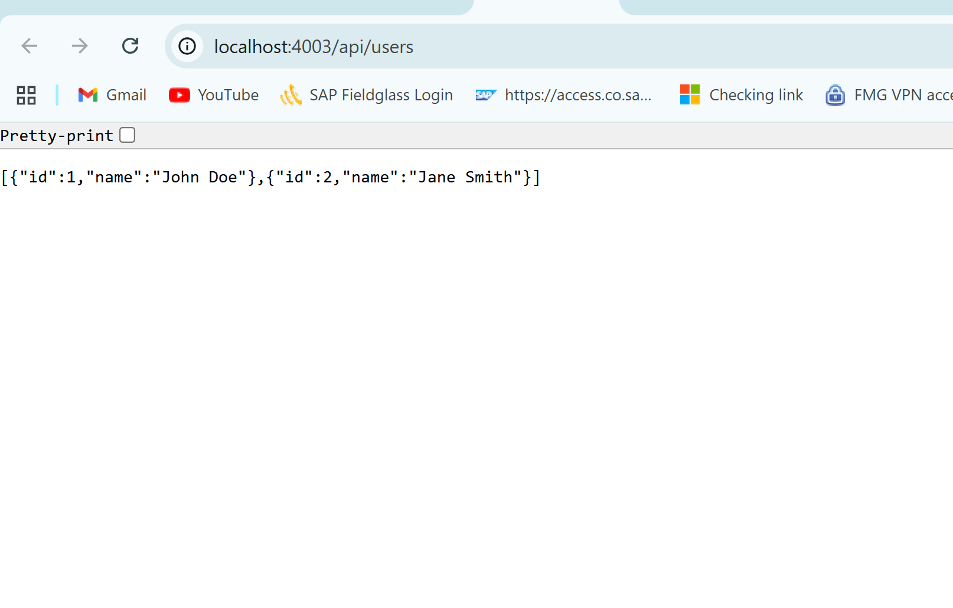
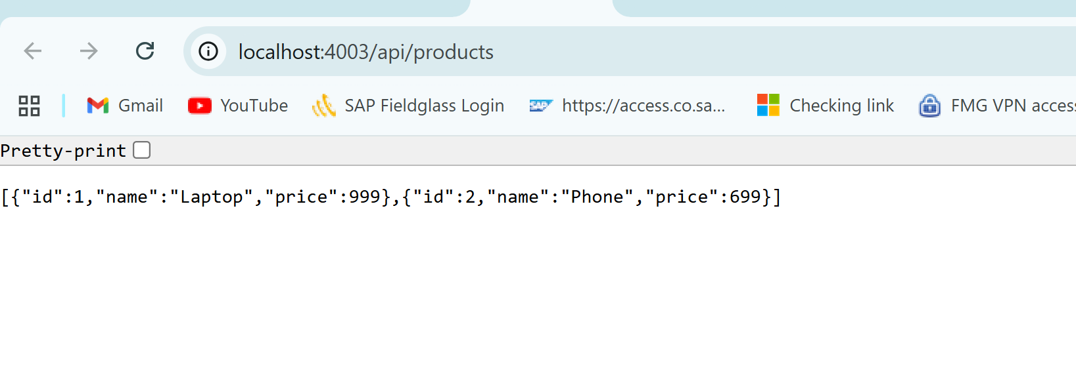
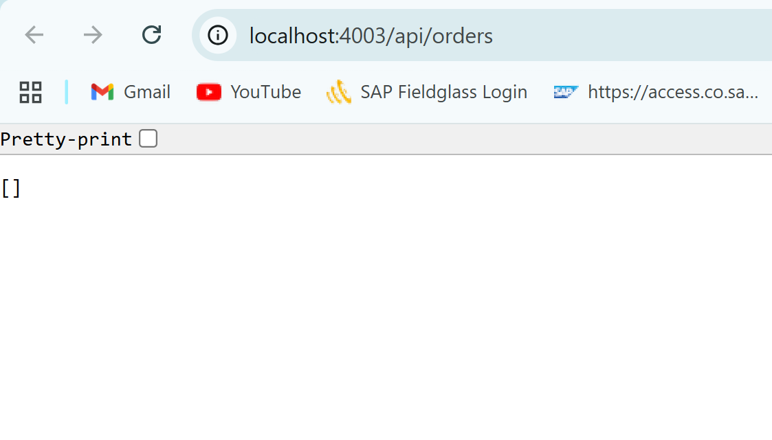

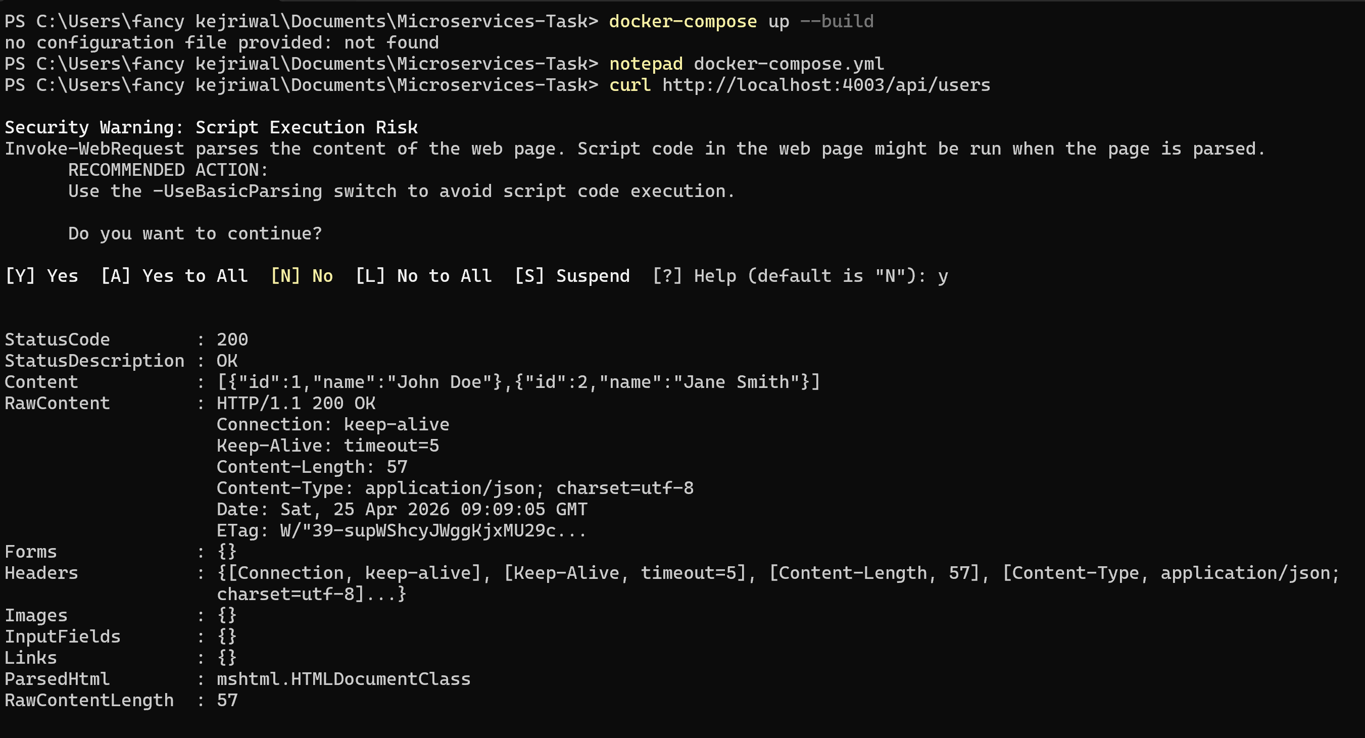
FINAL SUBMISSION STRUCTURE
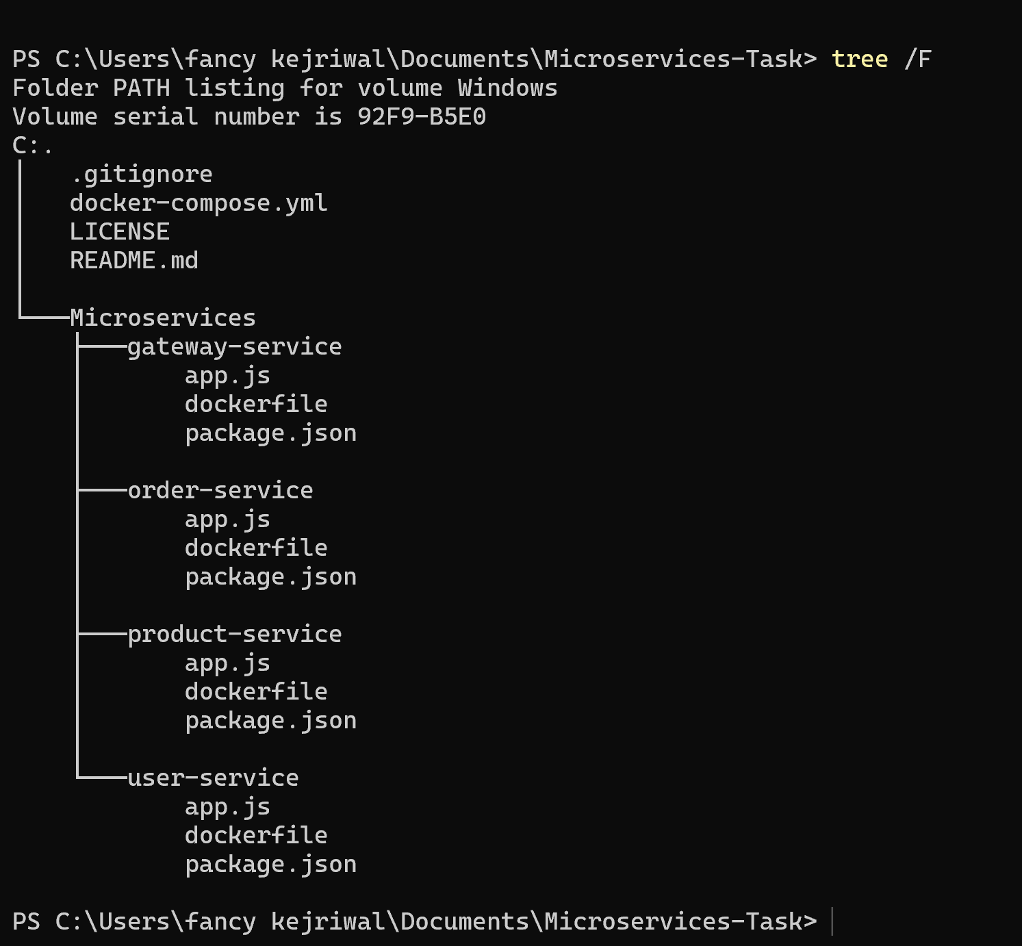

ISSUE faced during the assignment
I was facing issue with the port as below error
Attaching to gateway-service-1, order-service-1, product-service-1, user-service-1 user-service-1 | User service running on port 3000 Error response from daemon: failed to set up container networking: driver failed programming external connectivity on endpoint microservices-task-order-service-1 (a10ddc8627a51da69e142eb2b7cdae1151e40f368ecb7998540affb9bc91520a): Bind for 0.0.0.0:3002 failed: port is already allocated PS C:\Users\fancy kejriwal\Documents\Microservices-Task>

Solution- I have updated all the ports in docker-compose.yaml as below updated port and my issue got resolved.
services:
user-service:
ports:
- "4000:3000"

product-service:
ports:
- "4001:3001"

order-service:
ports:
- "4002:3002"

gateway-service:
ports:
- "4003:3003"
